The Four Stages of Success

#1
Questions:
(a) How do you define success?
(b) In your opinion, what steps are required to achieve this success?

#2
Pirkei Avos 5:23
Rabbi Yehuda Ben Teima says: Be bold as leopard, light as an eagle, swift as a gazelle, and mighty as a lion to do the will of your Father in Heaven.

Question: Why can't Rabbi Yehuda just tell us what to do without comparing these actions to these animals’ characteristics?

#3
Da’as Torah 1:181-182, Alei Shur 2:255
This Mishnah delineates four stages that are crucial to completing an act.

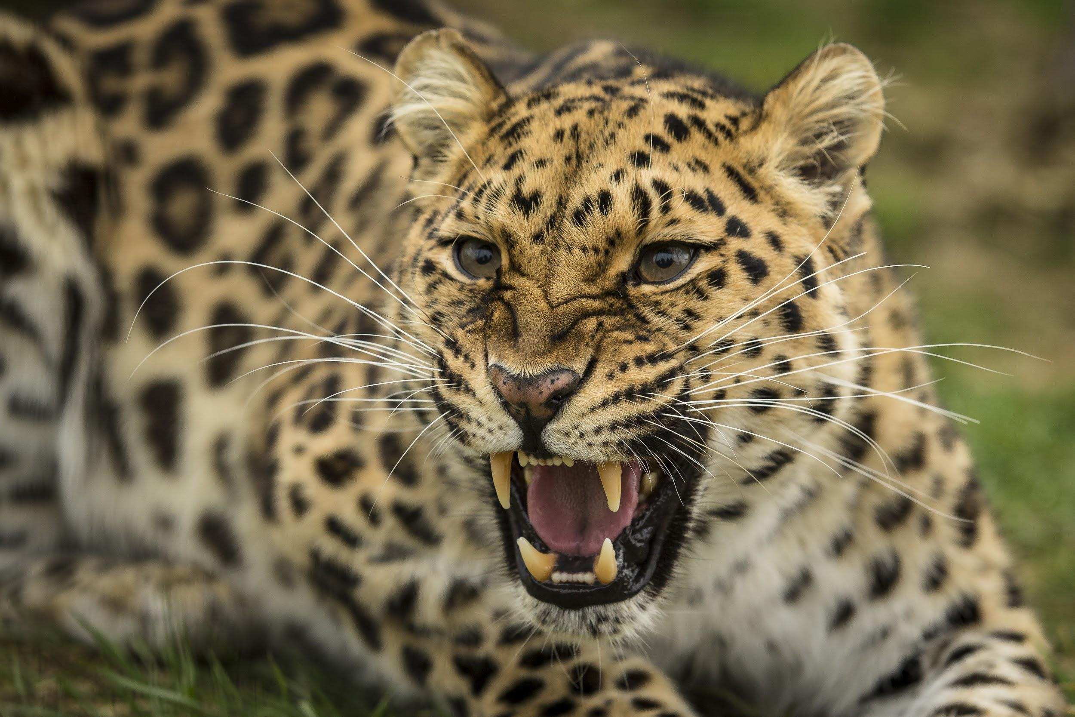
A. Stage One - Bold as a Leopard (Rabbi Dan Roth)
The first step in any action is to decide to do it. For this, one needs boldness - the ability to face up to the challenge without being overwhelmed by the magnitude of the task or being deterred by apparent barriers. The leopard exhibits both these aspects of boldness.
Firstly, it isn't frightened away by the magnitude of its quarry; it attacks animals up to four times its size (Ecological Aspects of Social Evolution, 433, D.I. Rubenstein and R.W. Wrangham).
And, secondly, it hunts in all types of climates, allowing neither scorching heat nor extreme cold to stand in its way (Milei D’Avos).
The leopard is an “opportunist,” taking advantage of potential kills wherever and however they present themselves (The African Leopard, T.N. Bailey).

Questions:
(a) How do we apply this idea in real life?

(b) The very next Mishnah states, “The brazen-faced person goes to Gehinnom (hell).”
Pirkei Avos 5:24
The brazen-faced person goes to Gehinnom (hell)…
The trait of boldness is described as a terrible and destructive force.
Explain the seeming contradiction!

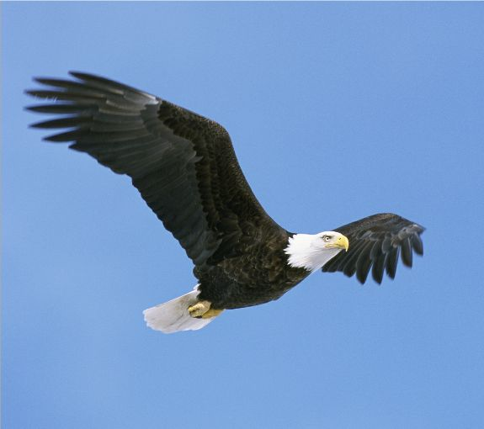
B. Stage Two - Light as an Eagle
Having accepted the challenge, we need to be “light as an eagle” in order to follow through to completion.
Eagles are one of the heaviest types of birds. The word “light” does not refer to physical weight, but rather, to the ability to do something without tiring.
Merriam-Webster's Collegiate Dictionary
Light - exerting a minimum of force or pressure;
Requiring little effort.
The eagle’s flight is effortless. Should it decide to travel to a particular place, it does not set out in that direction at once. It first flies upward in circles, spiralling increasingly higher until it reaches a height (sometimes up to 8,000 feet) from which it will be able to fly towards its destination in one continuous glide through the air without having to move once, on occasion more than twenty miles away (The Golden Eagle, Gordon).

Being light as an eagle, then, means meeting challenges in such a way so as not to wear oneself out and quit in the middle.
Instead of generating all energy itself, which would exhaust very quickly, the eagle positions itself where it is able to harness an independent force of nature - the wind - to carry it along smoothly.

Question: Which perpetual force will carry you along, ensuring that you not lose hope and give up in the middle?

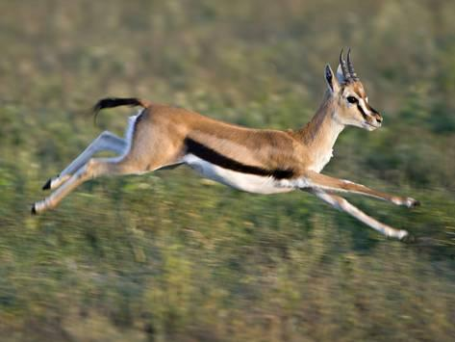
C. Stage Three - Swift as a Gazelle
Doubts begin to surface: “Perhaps I was being too ambitious when I accepted this commitment? Maybe I was aiming too high and expected too much of myself?”
At such times, one mustn't hesitate, but must push forward running like a gazelle.
In order to escape from several predators, it has to run swiftly, as fast as it can. It can't afford to stop and think, but must put all its energy into running. Even a moment's hesitation could mean death.

Questions:
(a) Does it mean that a person doesn't have to know his limitations and can overextend himself?
(b) How do we apply this idea in real life?

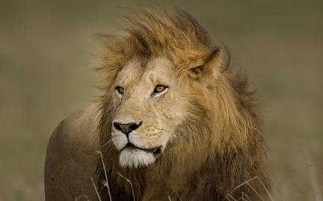

D. Stage Four Mighty as a Lion
The inherent danger in conclusions is that one will try to end the project before its proper time. No one likes unfinished business, and for the sake of “wrapping it up” there is a tendency to finish a project prematurely, just to have it behind and no longer weighing on your mind.
The Torah says that the lion “ ... does not lie down until it eats prey, and drinks the blood of the slain (Bamidbar 23:24).
The lion is used as the metaphor for completing a task and not resting until a mission is fulfilled, which in the lion's case is capturing prey.
When food is scarce and there is nothing else to eat, other animals will make do with whatever they can get their paws on. The lion, however, will not settle for anything other than real meat.
The lion as the king of the animal world always demands the best - even when something else is available.

Questions:
(a) What are some examples for this?

(b)
Bereishis Rabbah 85:3
Anyone who started doing a Mitzvah and did not finish it, and someone else came and finished it, it is attributed to the second one.

Why wouldn’t the first one get any credit?

#4
Question: What's your takeaway from today's discussion?

